# Chapter 2: Financial Math

## Section 2.5: Credit Cards

Credit cards are a common source of loan money, and therefore a common source of debt which must be repaid. There are much fewer and lower barriers to obtaining and using a credit card than there are to obtaining, for example, a mortgage. As such, there are some drawbacks both in terms of typically higher interest rates, as well as some structural differences. These structural differences actually mean that we will not be able to use the same formulas as we have for car loans, home loans, and student loans.

Perhaps most importantly, there is no set length of the loan (*t* in the previous formulas). The credit card company would be perfectly happy if the customer were to continually pay back less than the interest charged, in an endless cycle. Recall that this was specifically *not* allowed in the other types of loans we’ve looked at; for example, a typical mortgage is paid off in 30 years (if not sooner due to selling the house, making larger than necessary payments, etc). There are monthly minimum payments, but these do not guarantee repayment in a set amount of time. Rather, they are amounts that must be paid in order for your credit card account to remain in good standing – in other words, in order to be able to continue using the card and to avoid being charged late fees and eventually sent to collections.

**Important note:** the calculations in this section *only* deal with *direct repayments* of credit card debt. Actual bills very often also include *fees*, which you have to pay to the credit card company but do not actually reduce the amount of money owed.

### Agreements and Statements

A credit card agreement describes the policies and rates which apply to any specific credit card. Here is an example of a credit card agreement:

*(insert example of agreement here, or excerpts from it, possibly one from this database:*

<https://www.consumerfinance.gov/credit-cards/agreements/>*)*

*(insert comments on statement interpretation and highlights – specifics depends on choice of example)*

A billing statement shows various current information on a credit card account, such as the outstanding balance, the amount of the next minimum monthly payment, and its due date. Here is an example of a credit card monthly statement:

*(insert example of statement here, or excerpts from it, possibly one of the following:*

- <https://www.discover.com/credit-cards/resources/how-to-read-a-credit-card-statement/>

- <https://www.greatlakeslink.com/mglstatic/borrower/fiq/pdf/sample_credit_card_statement_fiq.pdf>

- <https://talkingcents.consumercredit.com/wp-content/uploads/2012/02/Sample-Credit-Card-Statement-11.pdf>

- *an actual statement, with individual info and bank/card name redacted)*

*(insert comments on statement interpretation and highlights – specifics depends on choice of example)*

### Monthly Minimum Payment Formulas

The key feature that differentiates credit cards from other types of loans (like a mortgage or a student loan) is that there is no fixed time period that the entire loan must be paid off by. Instead, there is a **monthly minimum payment**. An amount higher than the minimum could be paid, and the higher the amount, the sooner the debt will be paid off, and the lower the total amount of money paid to the credit card company.

Let’s look at a couple examples before diving into the formulas. (For the sake of making the process easier to follow, rounding is performed at each step; note however that, as always, this introduces some small error and it is better to only round on the final step.)

Example 1:

Azmi gets a credit card from Company A, with 19.99% APR compounding daily. He uses the card to buy a $1000 laptop. He does not make any payments during the 10-day interest-free grace period. His next payment is due 30 days later, i.e. 40 days since the purchase date. Thus, his outstanding balance is $\$1000{\left(1+\frac{.1999}{365}\right)}^{40}≈\$1022.14$.

Following the fine print in the credit card agreement, the minimum payment is calculated by Company A to be 2% of this outstanding balance after applying the APR; or $25, whichever is larger.

“Applying the APR” would be $1022.14(1+.1999)≈$1226.46.

Two percent of that figure is .02($12226.46)≈$24.53.

However, $24.53 is not larger than $25.

So Azmi’s first payment must be at least $25 if he wants to avoid any penalties.

Example 2:

Bilqis gets a credit card from Company B, with 17.99% APR compounding daily. She uses the card to buy a $900 plane ticket. She does not make any payments during the interest-free grace period. Her first payment is due 35 days since the grace period ended. Thus, her outstanding balance is $\$900{\left(1+\frac{.1799}{365}\right)}^{35}≈\$915.66$.

Following the fine print in the credit card agreement, the minimum payment is calculated by Company B to be one percentage point more than the APR of this outstanding balance; or $25, whichever is larger.

“One percentage point more than the APR of this outstanding balance” would be $915.66(.01+.1799)≈$173.88.

$173.88 is larger than $25.

So Bilqis’s first payment must be at least $172.18 if she wants to avoid any penalties.

We will need one more piece of mathematical notation before we can write down the formulas. This is to deal with that last step, where we have to decide whether something is larger than $25 or not. In general the **max function** takes a set of numbers as its input, and returns the largest member of that set as its output. The notation is “max{number 1, number 2, number 3, …}”. Here are a few examples:

max{1,2,3}=3 ; max{-3,-2,-1}=-1 ; max{5,0.5,0.25,0.125,-0.5,-2}=5 ; max{24.53,25}=25

As we can see, the methods used to calculate a monthly minimum payment differ by credit card, so be sure to read the fine print on your credit card bill. Azmi and Bilqis’s situations exemplify the two most common methods. These two methods lead to different formulas, even before we plug the specific numbers in:

* The first method (used with Azmi’s card) could be called “the company method”. We’ll call it this because it is the most common method actually used by credit card companies. In words: the monthly minimum payment is calculated by first applying the APR to the outstanding loan amount, and then finding 2% of that figure; or a flat $25, whichever is larger. In a formula: $$d=max\{\$25,.02P(1+r)\}$$ 
    
  As mentioned above though, it is important to read the fine print. For example, your credit card might use 3% instead of 2%, in which case we’d need to replace the “.02” in the formula with a “.03”. Also, it could be that the cutoff flat payment is something besides $25, such as $35.
* The second method (used with Bilqis’s card) could be called “the government method”. We’ll call it this because it is the method suggested for use by the US Department of the Treasury. Because it is just a suggestion and not a law, it is not used by hardly any credit card companies. In words: the monthly minimum payment is calculated as one percentage point more than the APR of the outstanding loan amount; or a flat $25, whichever is larger. In a formula: $$d=max\{\$25,P(.01+r)\}$$

### Billing Cycle

The credit card **billing cycle** consists of the interaction between the loan amount increasing via interest charges on the outstanding balance, and the loan amount decreasing via payments made by the customer.

*(insert flowchart here, possibly similar to this:*

<https://4.bp.blogspot.com/-wwQVgZeFZ7w/WhFsrpocNxI/AAAAAAAABqw/UH7p8yZLVlo1SylqOsgE4S1fTlo1ppWwACLcBGAs/s1600/CREDIT-CARD-BILLING-CYCLE-GRACE-PERIOD-EXAMPLE.jpg>*)*

Of course, as with any loan you may choose any repayment plan you’d like, so long as you pay at least the minimum for each payment. For example, you could use “the government method” to pay back your credit card debt faster, even if the minimum required is calculated using “the company method”. Or you could pay some constant amount every month. Or, with almost all cards, if you pay back the full amount before your next payment due date, they will not charge you any interest.

As for the compounding frequency, it is almost always daily compounding. (It could be something else like continuous or monthly, but this is very uncommon.)

The interest-free grace period is almost always from time of purchase until the next payment due date. (It could also be a set amount of time, such as 30 days, but this is very uncommon.) This grace period is only truly “interest-free” if you make a payment during that time. For any leftover amount that you didn’t pay, the interest will still have been compounding the entire time. Consider the following:

Example 3:

Chitra buys a $100 textbook with her new, previously unused credit card with 16.99% APR on March 15th. Her payment due dates are the 25th of every month.

On March 25th, she makes a payment to the credit card company of $50. Her new outstanding balance is $\$100-\$50=\$50$.

On April 25th, her next payment is due. Interest will be charged, compounding daily *since March 15th*, on that $50. There are 31 days in March, so that is $(31-15)+25=41$ days.

So Chitra’s outstanding balance on April 25th, before payment, is $\$50{\left(1+\frac{.1699}{365}\right)}^{41}≈\$50.96$.

Therefore her minimum payment due on April 25th is $25. (Check this yourself! Both “company” and “government” methods result in $25 after applying the max function.)

She pays the $25 and her new outstanding balance on April 25th, after payment, is $\$50.96-\$25=\$25.96$  
.

She makes no purchases with this credit card during the next month, so on May 25th her next payment is due, with interest having compounded daily over the 30 days between April 25th and May 25th. This results in a balance of $\$25.96{\left(1+\frac{.1699}{365}\right)}^{30}≈\$26.32$, and again the minimum payment is $25.

Not wanting to drag this on any longer, Chitra decides to send in the full $26.32 on May 25th, and her debt is now fully repaid.

So, the general process is as follows:

1. The customer makes a purchase using a credit card. They can repay the full amount by the next payment due date without being charged any interest. Otherwise…
2. The credit card company charges interest on the outstanding balance, compounding daily, until the next payment is made.
3. The minimum payment is calculated by the credit card company.
4. The customer either pays this minimum payment, or a higher amount.
5. Go back to step 2.

As you may have noticed, this process could be more complex in at least a couple ways. Firstly, the customer could make more purchases with the card before the previous amount has been fully repaid (until the card is maxed out, anyway). Secondly, if the customer fails to pay the minimum in step 4, then other bad things start to happen, such as late fees.

### Lifespan of a Credit Card Debt

Using these formulas, let’s look at a new example over more than one month.

Example 4a:

Drusilla has a credit card with an 18% APR compounding daily, and uses it to make a $1200 purchase on December 7th. The “company method” is used to calculate minimum payments, and she makes these minimum payments on the last day of each month.

On December 31st, her first payment is due. No interest has been charged, because of the grace period, so $P=1200$. The payment due is $d=max\{\$25,.02P(1+r)\}=max\{\$25,.02(\$1200)(1+.18)\}=max\{\$25,\$47.2\}=\$28.32$.

On January 31st, her next payment is due. It has been $m=(31-7)+31=55$ days, so the outstanding amount owed is $P_{new}=\left(P_{old}-d_{old}\right){\left(1+\frac{r}{n}\right)}^{m}=(\$1200-\$28.32){\left(1+\frac{.18}{365}\right)}^{55}≈\$1203.89$. Her payment is $d=max\{\$25,.02P(1+r)\}=max\{\$25,.02(\$1189.73)(1+.18)\}≈max\{\$25,\$28.41\}=\$28.41$.

On February 28th, he next payment is due. It has been $m=28$ days, so the outstanding amount owed is $P_{new}=\left(P_{old}-d_{old}\right){\left(1+\frac{r}{n}\right)}^{m}=(\$1203.89-\$28.41){\left(1+\frac{.18}{365}\right)}^{28}≈\$1191.81$. Her payment is $d=max\{\$25,.02P(1+r)\}=max\{\$25,.02(\$1191.81)(1+.18)\}≈max\{\$25,\$28.13\}=\$28.13$.

Continuing to follow this method, we have the results as shown in the table below:

|  |  |  |  |
| --- | --- | --- | --- |
| **Year** | **Payment date** | **Amount owed *(P)*** | **Payment amount *(d)*** |
| 0 | December 31 | $1200.00 | $28.32 |
| 1 | January 31 | $1203.89 | $28.41 |
| February 28 | $1191.81 | $28.13 |
| March 31 | $1181.61 | $27.89 |
| April 30 | $1170.92 | $27.63 |
| May 31 | $1160.89 | $27.40 |
| June 30 | $1150.38 | $27.15 |
| July 31 | $1140.53 | $26.92 |
| August 31 | $1130.77 | $26.69 |
| September 30 | $1120.53 | $26.44 |
| October 31 | $1110.94 | $26.22 |
| November 30 | $1100.88 | $25.98 |
| December 31 | $1091.46 | $25.76 |
| 2 | January 31 | $1082.11 | $25.54 |
| February 28 | $1071.26 | $25.28 |
| March 31 | $1062.09 | $25.07 |
| April 30 | $1052.48 | $25.00 |
| … | … | … | $25.00 |
| 7 | July 31 | $67.62 | $25.00 |
| August 31 | $43.27 | $25.00 |
| September 30 | $18.55 | $18.55 |

That’s right, it will take Drusilla 6.75 years to repay a credit card debt of $1200, if the APR is 18% and she only pays the monthly minimum! (Side note: we could make an adjustment for the leap year, but this would have a small effect and not change the number of payments required.) Notice that from April of the second year onwards, the payment is always $25. If we zoom in on that calculation, we have $d=max\{25,.02P(1+r)\}=max\{25,.02(1052.48)(1+.18)\}≈max\{25,24.84\}=\$25$. In other words, the “complicated part” of the formula spits out $24.84, but this is less than $25 so it’s not allowed. This continues until the very last month, when she owes less than $25: at this point she repays the total outstanding amount of $18.55.

Clearly this is not an efficient way to repay a loan. The credit company likes it just fine though: if we total all of the payments made by Drusilla, it comes to $2072.36. Since she only borrowed $1200 to begin with, their total profit was $872.36, or about 73% of the initial amount!

This is one of the main reasons behind the other formula, suggested by the Department of the Treasury. Let’s look at the same example, but this time using “the government method”, where $d=max\{\$25,P(.01+r)\}$.

Example 4b:

|  |  |  |  |
| --- | --- | --- | --- |
| **Year** | **Payment date** | **Amount owed *(P)*** | **Payment amount *(d)*** |
| 0 | December 31 | $1200.00 | $228.00 |
| 1 | January 31 | $998.72 | $189.76 |
| February 28 | $820.21 | $155.84 |
| March 31 | $674.60 | $128.17 |
| April 30 | $554.57 | $105.37 |
| May 31 | $456.12 | $86.66 |
| June 30 | $374.96 | $71.24 |
| July 31 | $308.40 | $58.60 |
| August 31 | $253.65 | $48.19 |
| September 30 | $208.52 | $39.62 |
| October 31 | $171.50 | $32.58 |
| November 30 | $140.98 | $26.79 |
| December 31 | $115.96 | $25.00 |
| 2 | January 31 | $92.36 | $25.00 |
| February 28 | $68.29 | $25.00 |
| March 31 | $43.96 | $25.00 |
| April 30 | $19.24 | $19.24 |

This way results in a repayment time of only $1.41\overline{6}$ years. The total profit made by the credit card company is a much more reasonable $90.06, or about 8% of the initial amount.

### Using Excel

As you may have guessed, it would take a long time (too long!) to do the calculations for example 4. Although there is no one shortcut formula due to the different number of days in each month, having to deal with the initial interest-free grace period, etc. Instead we will make an organized table in Excel, and take advantage of the “fill-down” feature which was described in section 2.1.

Example 4c:

Let’s reproduce the results of Example 4a, using Excel. We will need 5 columns for this process. For simplicity’s sake, let’s start with an empty sheet and use columns A through E. Let’s also use row 1 for column titles: “month” for the month number (“3” for March and so on), “m” for number of days that interest applied during that month, “P” for outstanding balance just before making a payment, “d” for payment amount, and “total d” for the total amount of all payments.

First, enter the number of days per month manually. Make sure to double-check with a calendar, and put “29” for February if it’s a leap year. Note that it says “24” for the first December, in cell B2. There are still 31 days of that December of course, but the purchase was made on December 7th. If you don’t want to do subtraction in your head, you can always type in “=31-7”.

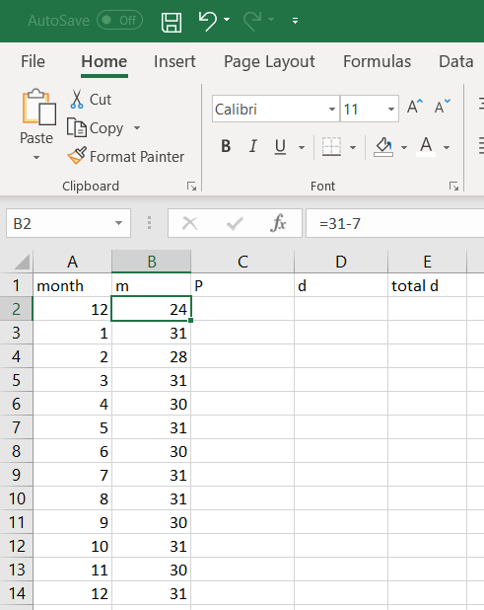

If it’s a large amount of debt, like $1200 in this case, then we can expect minimum monthly payments to need a long time for complete repayment. So we’ll need more than one year. Select cells A3 through B14 (by clicking and dragging), then copy this and paste it repeatedly underneath. Since this example was already done above we know it will take 7 years, so you should end up with numbers all the way through row 86.

Back at the top, the first outstanding balance is the purchase amount, so enter “1200” into cell C2. Recall that the first month is the interest-free period, so it really is just $1200 and some formula with $1200 as an input. Then in cell D2, enter the formula for the minimum monthly payment with Excel formatting. Drusilla’s card uses the company method, so that is the basic template. The max function in Excel is “MAX(number1,number2,…)”. We will refer to the value of *P* with the cell containing it, which is C2. Putting all of that together, we type “=MAX(0.02*C2*(1+0.18),25)” into cell D2, and after hitting enter it will display “28.32”.

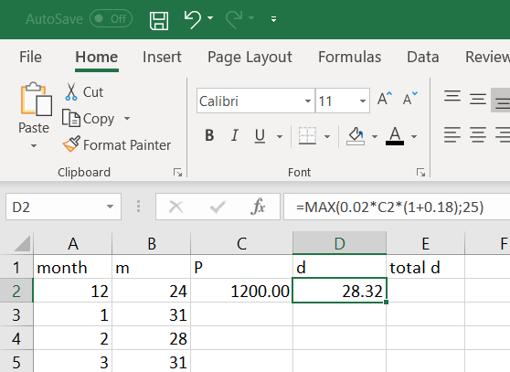

The grace period is over in January, so the outstanding balance in cell C3 will be December’s balance minus December’s payment, and then with interest applied over all of the days since the purchase. That is, B2+B3 days of interest applied to C2-D2 amount of money. This means we type “=(C2-D2)*(1+0.18/365)^(B2+B3)” into C3 and hit enter, resulting in 1203.89.

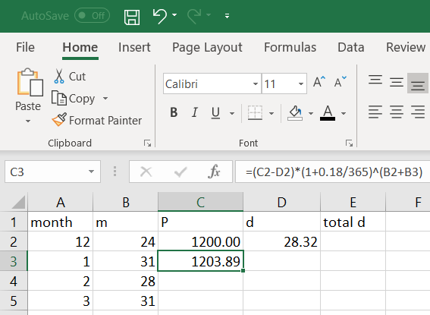

The payment for January is computed using exactly the same method as it was in December though, the only exception being that we want to refer to the balance in C3 rather than C2. Likewise, in March we’ll want C4, in April C5, and so on forever. We can use the fill-down feature to have Excel auto-fill this for us. Click on D2, release the click, and hover over the bottom-right corner of D2 so that the cursor is a small black “+”. Then click and drag downwards all the way to D86. Excel will display “25.00” for most of these, but that’s because it’s treating all those blank cells in column C as zeros, and the max{0,25}=25. We will fill in column C with the correct numbers shortly, but for now it should look like the screenshot below. Note that, for example, the formula for cell D17 includes a reference to C17.

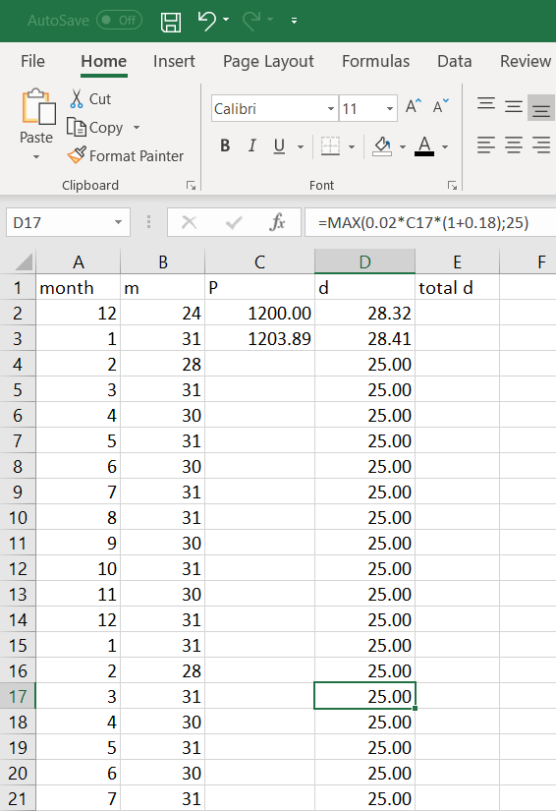

We don’t want to use fill-down on column C just yet, because our formula in C3 used “B2+B3” as the exponent, since the December days had to be retroactively included for interest purposes after the grace period ended, along with the January days. However in February, the new interest charges are only on the new days, i.e. the 28 days of February. This number 28 is conveniently found in cell B4. So in cell C4 we type “=(C3-D3)*(1+0.18/365)^B4”. After hitting enter, both C4 and D4 update to the correct numerical values.

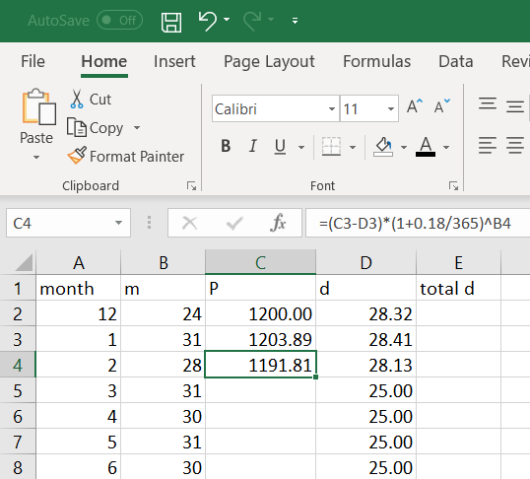

Now we can use fill-down for the outstanding balance amounts. Select C4, get its bottom-right corner, then click and drag all the way to C86.

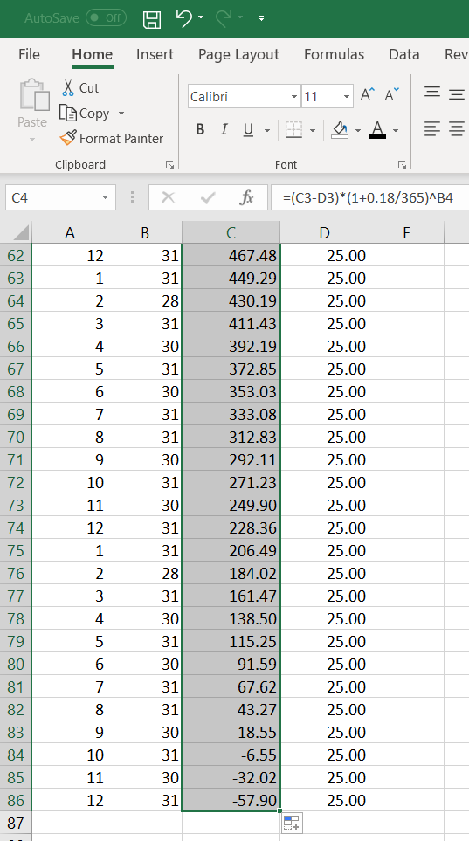

Note that the last three rows ended up having negative values in column C. We don’t want that, unless you plan to keep paying money to the credit card company so that they owe you money. But you wouldn’t be able to charge them interest unfortunately, so there’s no reason to do that. We need to fix the fact that we overshot: delete those rows. Click and drag to highlight A84 through D86, and hit the “delete” button.

That’s not all though. Cell D83 isn’t correct either: you don’t need to pay $25 when you only owe $18.55. So delete that too, and instead type “=C83” into D83.

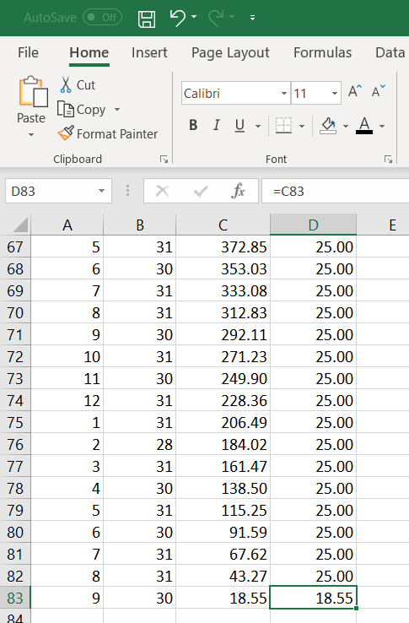

The debt is now repaid! Or at least the calculations for doing so are complete in Excel. Finally, let’s see how much money was spent in total. Back at the top, in cell E2, we can ask Excel to add up everything in column D: type “=SUM(D:D)” and hit enter.

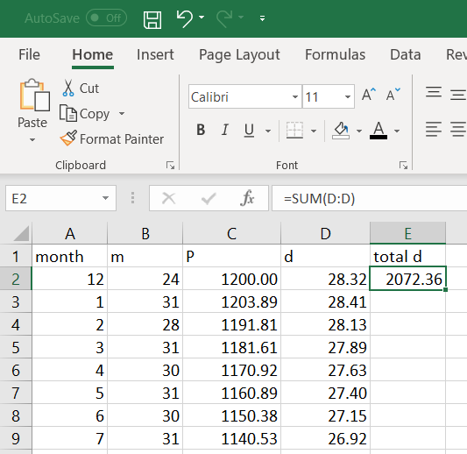

Additionally, if we want to know how many months it took, just subtract one from the row with the final payment (because row 1 has column titles in it and not numbers). That’s $83-1=82$ months.

You can use this same method for other interest amounts, purchase amounts, and repayment schemes. For example, to reproduce Example 4b (using the government method), you just need to edit the formula in D2 and then use fill-down to update the rest of column D.

You can also try out other financial planning ideas. You could, for example, make a flat payment of $200 every month: just enter “200” into D2 and use fill-down to update the rest of the column.

Note, however, that it gets complicated (not impossible, just complicated) if you make more purchases with the same card. For example if Drusilla were to use the card on July 11th of year 1 to make a $316 purchase, it would affect not only the formula in cell C9, but D9 and D10 as well. This is because besides adding $316 to the outstanding balance, we also have to deal with the fact that there is an interest-free grace period of July 11-31 – but only for that $316 and not the other $1140.53 debt from the original December 7th purchase.

The general process is as follows:

1. Enter the column titles in row 1.
2. Enter the months and days per month in columns A and B. Use copy/paste if multiple years are needed.
3. Enter the number of grace period days in B2 and the purchase amount in C2.
4. Enter the formula for interest growth in C3, including all days since the purchase.
5. Enter the formula for interest growth in C4, including the days of the current month only.
6. Enter the formula for monthly payment in D2. Make sure it is at least the minimum required by the credit card company, but it could be some other formula or flat amount that results in a higher number.
7. Use fill-down on columns C and D.
8. Delete any rows with negative numbers in them.
9. Edit the bottom-right-most filled cell, so that the final payment is exactly the remaining balance and not some higher amount.
10. If desired, calculate “=SUM(D:D)” to get the total amount of all payments made.

### Length of Repayment Period

Often, an individual wants to pay off their credit card debt within a certain amount of time. Due to the complexity of the formulas – in particular the max function and the different number of days in each month – we cannot simply do some algebra and get a formula where the output is monthly payment and one of the inputs is total repayment time (or number of monthly payments).

What we *can* do though, is to use the estimation method presented at the end of section 2.4, and then plug this estimate in to the more detailed method from this section.

Example 5:

Siufan uses a credit card with 20% APR to buy a video game console for $500 on April 16th. The “company method” is used to calculate minimum payments, and she makes payments on the last day of each month. She decides to pay it off in one year. If she doesn’t buy anything else with the same card, how much will her monthly payments be?

The rough estimate is $d=\frac{P\left(\frac{r}{n}\right)}{1-{\left(1+\frac{r}{n}\right)}^{-nt}}\left(\frac{365}{12}\right)=\frac{\$500\left(\frac{.2}{365}\right)}{1-{\left(1+\frac{.2}{365}\right)}^{-365(1)}}\left(\frac{365}{12}\right)≈\$45.98$.

We can get the same amount using Excel, by typing: “=PMT(.2/365,365,-500,0)*365/12”.

We need to check that this is more than the monthly minimum payment every month, or she will end up with penalties. The minimums go down as the outstanding balance goes down (until it flatlines at $25 minimum anyway). Therefore we only need to compare to the first and second month’s minimums; we are including the second to err on the safe side, since there is no interest charged during the grace period.

On April 30th, no interest has been charged, because of the grace period, so $P=\$500$. The minimum payment due is $d=max\{\$25,.02P(1+r)\}=max\{\$25,.02(\$500)(1+.2)\}=max\{\$25,\$12\}=\$25$. Thus her planned payment of $45.98 is above the minimum and she’s safe to pay that amount.

On May 31st, her next payment is due. It has been $m=(30-16)+31=45$ days, so the outstanding amount owed is $P_{new}=\left(P_{old}-d_{old}\right){\left(1+\frac{r}{n}\right)}^{m}=(\$500-\$45.98){\left(1+\frac{.2}{365}\right)}^{45}≈\$465.35$. Her minimum payment is $d=max\{\$25,.02P(1+r)\}=max\{\$25,.02(\$465.35)(1+.2)\}≈max\{\$25,\$11.17\}=\$25$. Again, this is less than $45.98 so she is safe to continue paying that much per month.

Turning to Excel, applying the interest and the flat $45.98 payment each month, we find that the debt is indeed completely paid off by the end of one year. The final payment on March 31st of the next year would only need to be $35.87.

### Summary of Formulas

Monthly minimum payment (company method): $d=max\{\$25,.02P(1+r)\}$

*

Monthly minimum payment (government method): $d=max\{\$25,P(.01+r)\}$

Monthly minimum payment (repayment in *t* years): $d=\frac{P\left(\frac{r}{n}\right)}{1-{\left(1+\frac{r}{n}\right)}^{-nt}}\left(\frac{365}{12}\right)$

**

Pre-payment balance after applying interest: $P=\left(P_{old}-d_{old}\right){\left(1+\frac{r}{n}\right)}^{m}$

*d* is the payment amount

*P* is the outstanding balance owed

*r* is the APR in decimal form

*n* is the compounding frequency per year (almost always *n*=365)

*m* is the number of days since the previous payment ***

*Pold* is the previous pre-payment outstanding balance

*dold* is the previous payment amount

* Check your credit card agreement for specifics. For example, different figures besides   
 “25” and “.02” may be used.

** This is an estimate. Check that (1) *d* is at least the minimum required by the credit   
 card company, and (2) *P* really does go to zero in *t* years or less.

*** Take care in counting *m* accurately when dealing with the interest-free period.

### Excercises 2.5

1. Evaluate each expression:
   1. max{0,1,5,11}
   2. max{11,5,1,0}
   3. max{0,-1,5,-11}
2. Evaluate each expression:
   1. max{25.00,25.45}
   2. max{35.00,34.95}
   3. max{18.12,19.17,20.19,14.92}
3. Your credit card debt is $8435.61, on a card with 19.5% APR. You are past the grace period. The monthly payment is due today.
   1. How much do you have to pay, according to the default company method?
   2. How much should you pay, according to the government method?
   3. Are you allowed to pay the amount in part b? Why or why not?
4. Your credit card debt is $1653.48, on a card with 22.99% APR. You are past the grace period. The monthly payment is due today.
   1. How much do you have to pay, according to the default company method?
   2. How much should you pay, according to the government method?
   3. Are you allowed to pay the amount in part b? Why or why not?
5. For what range of APR rates does the government method result in a *lower* payment than what’s required by the default company method? Assume that *P* is high enough that both payments would be more than $25. (Hint: use algebra with the appropriate formulas.)
6. You have just gotten a new credit card with 18% APR. Today is April 16, 2020. You make a $400 purchase. Payments are due on the 1st of each month. Reading the fine print, the company requires a “minimum payment of 2% of the outstanding balance after applying the APR, or $25, whichever is larger.” The interest-free grace period lasts from the date of purchase until the end of the month. Assume you make no further purchases with the same card.
   1. Calculate the outstanding balance on July 1st (after that day’s payment), using the company method.
   2. Calculate the outstanding balance on July 1st (after that day’s payment), using the government method.
   3. Calculate the outstanding balance on July 1st (after that day’s payment), if you pay a flat $100 each month.
7. You have just gotten a new credit card with 21% APR. Today is October 30, 2020. You make a $4000 purchase. Payments are due on the 1st of each month. Reading the fine print, the company requires a “minimum payment of 2% of the outstanding balance after applying the APR, or $25, whichever is larger.” The interest-free grace period lasts from the date of purchase until the end of the month. Assume you make no further purchases with the same card.
   1. Calculate the outstanding balance on January 1st (after that day’s payment), using the company method.
   2. Calculate the outstanding balance on January 1st (after that day’s payment), using the government method.
   3. Calculate the outstanding balance on January 1st (after that day’s payment), if you pay a flat $100 each month.
8. You have just gotten a new credit card with 22.9% APR. Today is January 7, 2020. You make $5498.33 in purchases. Payments are due on the 1st of each month. Reading the fine print, the company requires a “minimum payment of 3% of the outstanding balance after applying the APR, or $35, whichever is larger.” The interest-free grace period lasts from the date of purchase until the end of the month. Assume you make no further purchases with the same card.
   1. Calculate the outstanding balance on April 1st (after that day’s payment), using the company method.
   2. Calculate the outstanding balance on April 1st (after that day’s payment), using the government method.
   3. Calculate the outstanding balance on April 1st (after that day’s payment), if you pay a flat $500 each month.
9. Use the situation from exercise #6. Assume you make no further purchases with the same card.
   1. Using the company method, how many monthly payments do you make in order to completely pay it off? How much money do you pay in total?
   2. Using the government method, how many monthly payments do you make in order to completely pay it off? How much money do you pay in total?
   3. If you pay a flat $100 every month (until you owe less than $100), how many monthly payments do you make in order to completely pay it off? How much money do you pay in total?
10. Use the situation from exercise #3. Your goal is pay off the debt within 2 years. Assume you make no further purchases with the same card.
    1. Estimate monthly flat payment needed to achieve your goal.
    2. Check that your answer from part a is higher than the monthly minimum for all months. What is the actual number of monthly payments needed? What is the amount of the final month’s payment? How much money do you pay in total?
11. Use the situation from exercise #4. Your goal is pay off the debt within 2 years. Assume you make no further purchases with the same card.
    1. Estimate monthly flat payment needed to achieve your goal.
    2. Check that your answer from part a is higher than the monthly minimum for all months. What is the actual number of monthly payments needed? What is the amount of the final month’s payment? How much money do you pay in total?